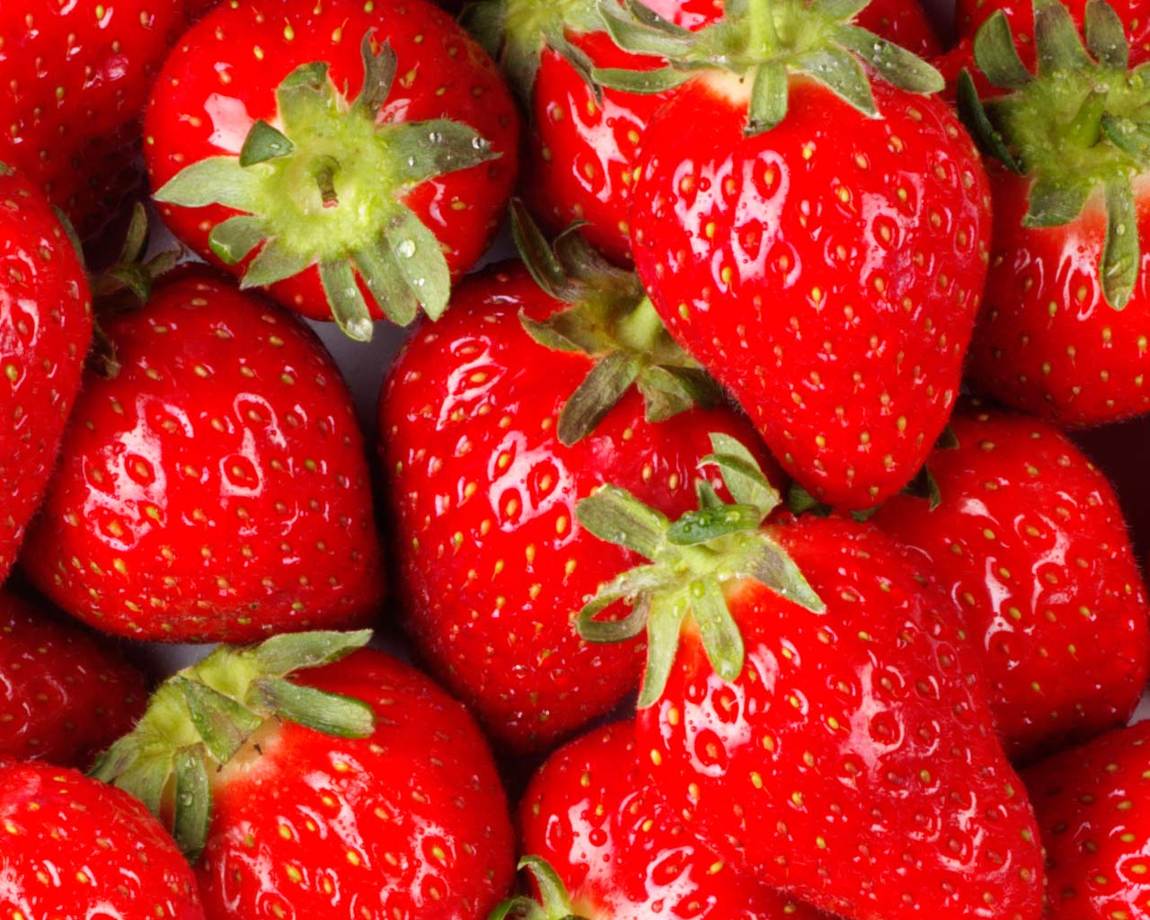

**Summer strawberry cream tea**

If you are in need of cheering up or have a special day coming up, why not order the delicious strawberry afternoon tea package

Teas contain:

A selection of sandwiches with traditional fillings such as smoked salmon with cream cheese and cucumber, gammon and wholegrain mustard mayo, cheese and homemade apple chutney, egg and cress.

Smoked salmon pinwheel pastries

Cheese straws

Sausage rolls

Mini Victoria sponge

Strawberry shortcake

Chocolate dipped strawberries

Strawberry Eaton mess in teacups

Scones with clotted cream and strawberry jam and fresh strawberries

Tea and coffee

£17.95 per person

Vegetarian options are available